SIMATS ENGINEERING
ASSESSMENT TOOL 2
COURSE NAME: CSA1613 COURSE CODE: Data Warehousing and Data Mining

COURSE OUTCOME COVERED
CO4: Examine the applicability of clustering algorithms in real-world scenarios, presenting findings through clear reports with effective visualizations.
Assessment Tool Weightage: 20%

QUESTIONS: 05 Total Marks:50
Annexure A

COMPARITIVE ANALYSIS
Criteria | Scope of Items (2) | Comparison Depth(2.5) | Use of  Evidence  (2) | Critical  Thinking (2) | Clarity of  Presentation (1) | Total(10  )
Weightag e | 20% | 25% | 20% | 20% | 10% | 100%
Q1
Q2
Q3
Q4
Q5

Code of Conduct:
I __K.Nagapreetham(192525242)_ (Name / Reg No) certify that this submission is my original work and that I have adhered to the guidelines specified for this assessment.
I understand that any violation of academic integrity rules will result in disciplinary action.
Signature of the student:
RUBRICS FOR CALCULATION:
 |  | Comparative analysis
Criteria | Weightag e (%) | Level 4 (Exemplary) | Level 3 (Proficient) | Level 2  (Developing  ) | Level 1 (Beginning)
Scope of Items | 20% | Selects highly relevant items with clear scope and justification | Selects appropriate items with minor gaps | Selection is limited or partially relevant | Items are unclear or not relevant
Compariso n Depth | 25% | Provides detailed and comprehensive comparison across multiple aspects | Provides adequate comparison with some depth | Limited comparison with few aspects | Very minimal or no comparison
Use of Evidence | 20% | Supports comparison with accurate data, examples, or references | Uses some supporting evidence with minor gaps | Limited or weak supporting evidence | No supporting evidence provided
Critical Thinking | 20% | Demonstrates strong critical thinking with clear interpretation and reasoning | Shows reasonable interpretation with minor gaps | Basic interpretatio  n; lacks depth | No meaningful  interpretatio  n
Clarity of Presentatio n | 15% | Well-organized, clear, and logically structured presentation | Generally clear with minor issues | Somewhat  unclear or poorly structured | Disorganize d and  difficult to  understand
Annexure A
Q1 . Dataset: Assessment Tool 2: Comparative Analysis (25% → 5
Marks)
Time duration :45 Minutes Assessment Tool 3 (Low)
Q1 . Dataset: Customer Data Customer Income (₹) Spending Score
C1 30000 60
C2 60000 40
C3 50000 70
C4 28000 65
C5 65000 35
Question:
Compare K-means and hierarchical clustering using this dataset and explain differences in performance and scalability. (BL3 – 1 Mark)
Q2. Dataset: Document Data
Document Word1 Word2 Word3
D1 0.2 0.5 0.3
D2 0.1 0.6 0.3
D3 0.8 0.1 0.1
D4 0.75 0.15 0.1
D5 0.2 0.4 0.4
Question:
Compare K-means and EM algorithms in handling overlapping clusters for the given dataset. (BL4 – 1 Mark)
Q3. Dataset: Geographic Data
Point Latitude Longitude
P1 13.08 80.27
P2 13.10 80.25
P3 12.97 80.22
P4 13.05 80.30
P5 13.00 80.20
Question:
Compare Euclidean and Manhattan distance metrics and analyze their impact on clustering results. (BL4 – 1 Mark)
Q4. Dataset: Retail Products Product Sales (₹) Frequency
P1 | 50000 | 20
P2 | 30000 | 10
P3 | 52000 | 22
P4 | 25000 | 8
P5 | 32000 | 12
Question:
Compare agglomerative and divisive clustering approaches and explain their suitability for this dataset. (BL3 – 1 Mark)
Q5 . Dataset: Mixed Attributes Item Price (₹) Category Rating
I1 | 500 | A | 4.5
I2 | 300 | B | 3.8
I3 | 550 | A | 4.7
I4 | 250 | B | 3.5
I5 | 520 | A | 4.6
Question:
Compare centroid-based and density-based clustering techniques and analyze their effectiveness on mixed data types. (BL4 – 1 Mark)

Q1. Compare K-Means and Hierarchical Clustering
Given Dataset
Customer | Income (₹) | Spending Score
C1 | 30,000 | 60
C2 | 60,000 | 40
C3 | 50,000 | 70
C4 | 28,000 | 65
C5 | 65,000 | 35
K-Means Clustering:
K-Means is a partition-based clustering algorithm that divides data into a predefined number of groups called clusters. Each cluster is represented by a centroid, which is the mean of the points belonging to that cluster.
Formula:
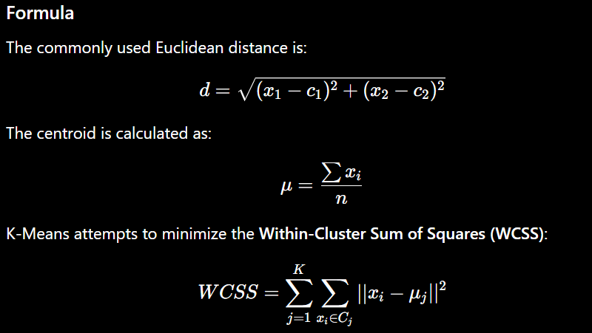
Step 1: Select K
Suppose: K = 2
So, the customers are divided into two groups.
Step 2: Select initial centroids
Assume two initial centroids are selected from the dataset.
Step 3: Calculate distance
For example, take C1 = (30000,60) and centroid = (28000,65).
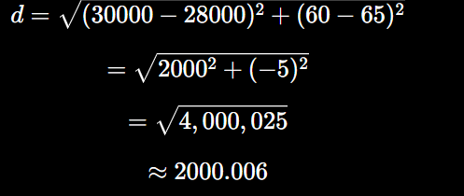
The same calculation is performed for all customers.
Step 4: Assign customers
Each customer is assigned to the closest centroid.
Customers such as C1 and C4 are similar because they have relatively low income and high spending scores. C2 and C5 are also similar because they have high income and relatively low spending scores.
Step 5: Recalculate centroid
For example, if C1 and C4 form a cluster:
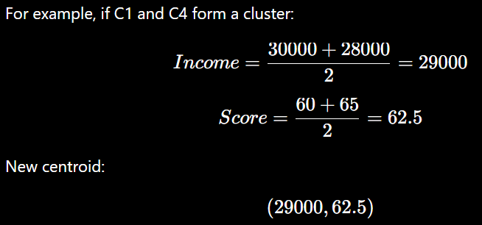

Step 6: Repeat the assignment and centroid calculation until the clusters become stable.
Hierarchical Clustering
Hierarchical clustering creates a tree-like hierarchy of clusters. Agglomerative hierarchical clustering starts with each customer as an individual cluster and gradually merges similar clusters.
Steps
- Consider every customer as a separate cluster.
- Calculate the distance between customers.
- Find the closest two clusters.
- Merge them.
- Recalculate distances.
- Continue until all customers form one hierarchy.
- Use a dendrogram to select the required number of clusters.
and then further merge depending on the distance and linkage method.
Performance and Scalability Comparison:
K-Means | Hierarchical
Centroid-based | Hierarchy-based
Requires K initially | K can be selected from dendrogram
Faster | Usually slower
Good scalability | Less scalable
Suitable for large datasets | Suitable for small datasets
Produces clusters | Produces hierarchy/dendrogram
Conclusion:
For this small customer dataset, both methods can be used. Hierarchical clustering gives a better view of relationships between customers, while K-Means is more suitable for large customer datasets because of its speed and scalability.

Q2. Compare K-Means and EM algorithms in handling overlapping clusters for the given dataset.
Given Dataset
Document | Word1 | Word2 | Word3
D1 | 0.2 | 0.5 | 0.3
D2 | 0.1 | 0.6 | 0.3
D3 | 0.8 | 0.1 | 0.1
D4 | 0.75 | 0.15 | 0.1
D5 | 0.2 | 0.4 | 0.4
K-Means:
K-Means assigns each document to one cluster based on its distance from the centroid.
Formula:
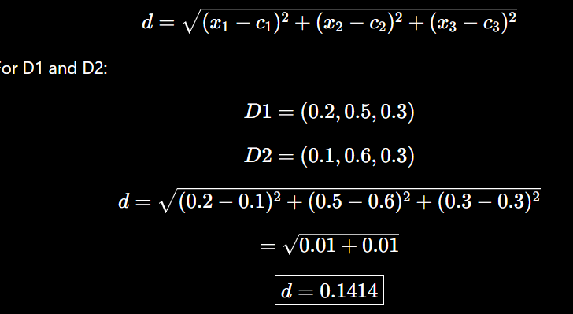
Therefore, D1 and D2 are similar.
Similarly, D3 and D4 have very similar values and are likely to be grouped together.
K-Means Steps
- Select .
- Select initial centroids.
- Calculate distances.
- Assign documents to nearest centroid.
- Recalculate centroids.
- Repeat until convergence.
EM Algorithm
EM stands for Expectation-Maximization. Unlike K-Means, EM can assign a document to clusters using probabilities, making it more suitable for overlapping clusters.
Probability formula:
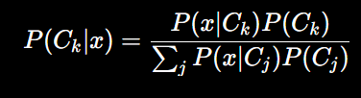
EM Steps:
- Initialize cluster parameters.
- E-Step: Calculate probability of each document belonging to each cluster.
- M-Step: Update cluster parameters.
- Repeat E-Step and M-Step until convergence.
For example, a document could have:
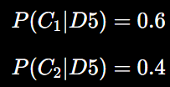
This means D5 has characteristics of both clusters.

Comparison:
K-Means | EM
Hard clustering | Soft clustering
One cluster membership | Probability of multiple memberships
Distance-based | Probability-based
Simple and faster | More computationally complex
Less suitable for overlapping clusters | Better for overlapping clusters
Conclusion
For the given document dataset, K-Means works well when documents are clearly separated, while EM is more suitable when documents have overlapping characteristics and may belong partially to more than one cluster.

Q3. Compare Euclidean and Manhattan distance metrics and analyze their impact on clustering results.
Given Dataset
Point | Latitude | Longitude
P1 | 13.08 | 80.27
P2 | 13.10 | 80.25
P3 | 12.97 | 80.22
P4 | 13.05 | 80.30
P5 | 13.00 | 80.20
Euclidean Distance
Euclidean distance represents the straight-line distance between two points.
Formula:
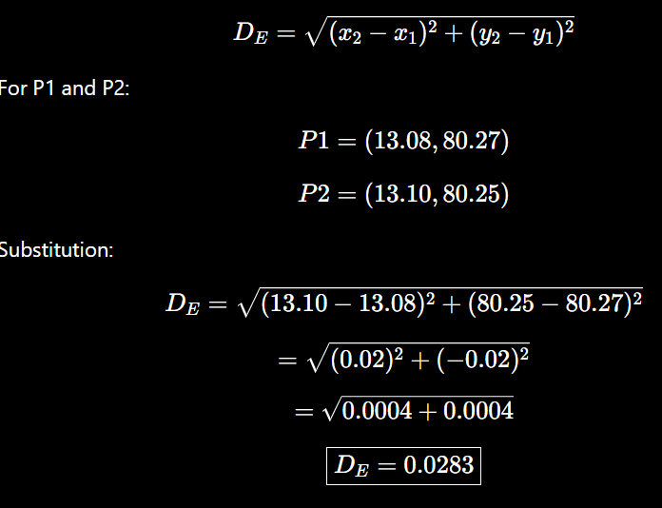
Manhattan Distance
Manhattan distance calculates the sum of absolute differences.
Formula:
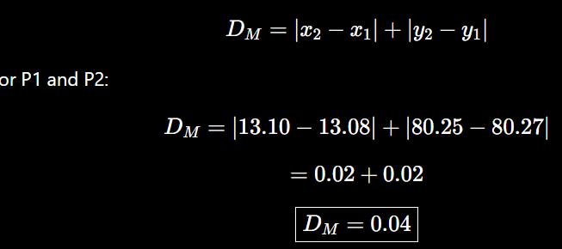
Impact on Clustering:
The two methods give different distance values.
- Euclidean: 0.0283
- Manhattan: 0.04
Therefore, the choice of distance metric can change which points are considered closest.
This can affect:
- Cluster formation
- Cluster membership
- Cluster boundaries
- Final clustering result
Comparison:
Euclidean | Manhattan
Straight-line distance | Sum of coordinate differences
Uses square root | No square root
More affected by large differences | Less affected by individual large differences
Common in geometric clustering | Useful for grid/high-dimensional situations
Conclusion:
For geographic numerical data, Euclidean distance gives direct geometric similarity, while Manhattan distance measures coordinate-wise differences. Choosing the appropriate metric is important because it can change the final clusters.

Q4. Compare agglomerative and divisive clustering approaches and explain their suitability for this dataset.
Given Dataset
Product | Sales (₹) | Frequency
P1 | 50,000 | 20
P2 | 30,000 | 10
P3 | 52,000 | 22
P4 | 25,000 | 8
P5 | 32,000 | 12
Agglomerative Clustering
Agglomerative clustering follows a bottom-up approach.
Formula:
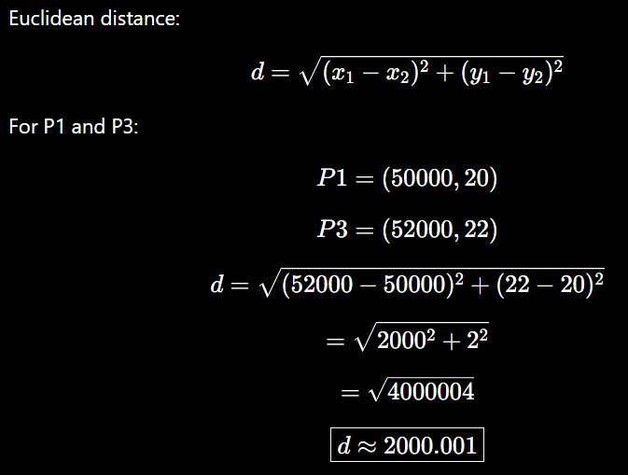
Thus, P1 and P3 are quite similar compared with products having much larger differences.
Steps:
- Start with every product as an individual cluster.
- Calculate distances.
- Find the closest products/clusters.
- Merge them.
- Recalculate cluster distances.
- Continue merging.
- Create a dendrogram.
- Select the required clusters.

Divisive Clustering:
Divisive clustering follows a top-down approach.
Steps
- Start with all products in one cluster.
- Divide the cluster into smaller groups.
- Identify groups that need further splitting.
- Continue splitting.
- Stop when the required number of clusters is obtained.
Comparison:
Agglomerative | Divisive
Bottom-up | Top-down
Starts with individual clusters | Starts with one cluster
Merges clusters | Splits clusters
Easier for small datasets | More computationally demanding
Builds hierarchy | Builds hierarchy
Suitability:
This dataset contains only five products, so both approaches can be applied.
Agglomerative clustering is more convenient because it can easily identify similar products such as:
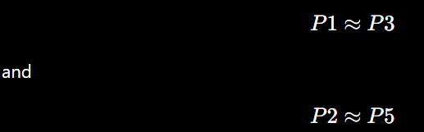
based on their sales and frequency.
Conclusion:
Agglomerative clustering is more suitable for this small retail dataset because it is simple and clearly shows the similarity between products.

Q5. Compare centroid-based and density-based clustering techniques and analyze their effectiveness on mixed data types.
Given Dataset
Item | Price (₹) | Category | Rating
I1 | 500 | A | 4.5
I2 | 300 | B | 3.8
I3 | 550 | A | 4.7
I4 | 250 | B | 3.5
I5 | 520 | A | 4.6
The dataset contains both numerical and categorical data.
- Price → Numerical
- Rating → Numerical
- Category → Categorical
Centroid-Based Clustering:
K-Means is an example of centroid-based clustering.
It groups items around a central point called a centroid.
Formula:
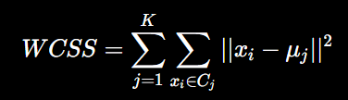
Steps:
- Select K.
- Select initial centroids.
- Calculate distances.
- Assign items to nearest centroid.
- Calculate new centroids.
- Repeat until convergence.
In this dataset, I1, I3 and I5 have:
- Category A
- High prices
- High ratings
Therefore, they show strong similarity.
I2 and I4 have:
- Category B
- Lower prices
- Lower ratings
So they can form another group.

Density-Based Clustering:
DBSCAN is an example of density-based clustering.
It forms clusters by identifying regions containing a high concentration of points.
Parameters:
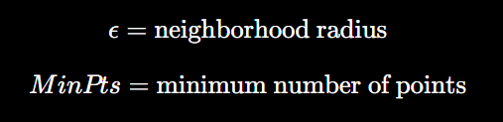
Core Point Formula:
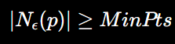
Steps:
- Select ε.
- Select MinPts.
- Find neighboring points.
- Identify core points.
- Expand dense clusters.
- Mark isolated points as noise.

Effectiveness on Mixed Data:
The main problem is that Category A and Category B are categorical values and cannot directly be used in ordinary Euclidean distance.
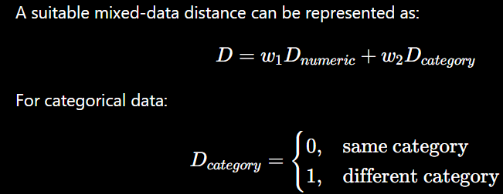
Therefore, preprocessing or an appropriate mixed-data clustering technique is required.

Comparison:
Centroid-Based | Density-Based
K-Means | DBSCAN
Uses centroids | Uses density
K is generally specified | K is not required
Good for compact clusters | Good for irregular clusters
Sensitive to outliers | Can detect noise
Needs numerical representation | Needs suitable distance for mixed data
Conclusion:
For the given dataset, the items naturally show two groups: I1, I3, I5 and I2, I4. Centroid-based clustering can identify these groups after suitable encoding/preprocessing. Density-based clustering can be useful when the data contains irregular clusters or noise. For mixed data, the choice of representation and distance measure is very important.

